Table of Contents

- Introduction

- project Objectives

- Data Source and Tools Used

- Overview of Metrics 4.1. Top 5 Batsmen 4.2. Top 5

- Wicket Takers

- Stadium Performance Analysis

- Team Performance Analysis

- Individual Player Analysis 7.1. Top Batsmen's Performance by Opposition 7.2. Top Wicket Takers' Performance by Opposition

- Insights from the Tournament 8.1. Trends in Batting 8.2. Trends in Bowling

- Impact of Venue on Performance

- Key Observations

- Conclusions

- Introduction

The ICC Men's Cricket World Cup 2023 was one of the most anticipated events in the sporting calendar, bringing together the world's top cricketing nations in a battle for the prestigious title. Held in India, this edition of the tournament spanned several iconic cricket venues, providing fans with thrilling matches, outstanding individual performances, and unforgettable moments. Cricket enthusiasts and analysts alike were eager to dissect every facet of the tournament, from team strategies to player form, as each match unfolded new dynamics and challenges. This project report delves deep into the key statistics and performance metrics from the World Cup, offering a comprehensive analysis through a detailed data visualization dashboard.
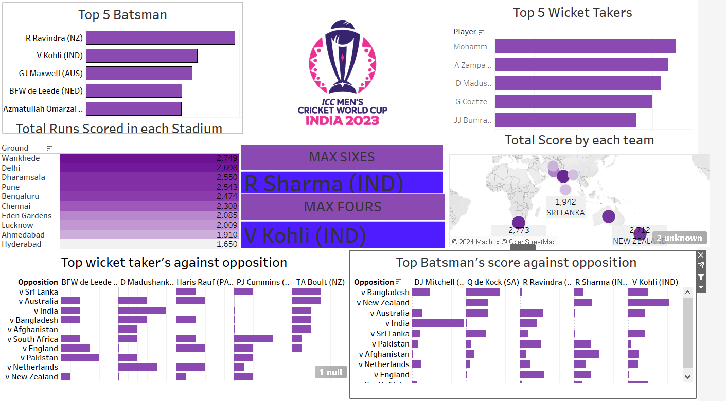
The purpose of this report is to provide insights into the standout performances, trends, and overall outcomes of the ICC Men's Cricket World Cup 2023. By using a data-driven approach, this report covers multiple aspects of the tournament, including top batsmen, wicket-takers, team performances, and the impact of various stadiums on game outcomes. The visualization, powered by Tableau, allows us to explore these data points interactively, making it easier to understand the tournament's highlights and underlying patterns.
At the heart of this analysis lies the performance of individual players who made a significant impact on their team's success. The top five batsmen, including New Zealand's Rachin Ravindra, India's Virat Kohli, and Australia’s Glenn Maxwell, were instrumental in setting competitive scores and chasing targets. Their consistency and ability to perform under pressure are explored in detail in this report. Additionally, we examine the contributions of top bowlers like India's Mohammad Shami and Australia’s Adam Zampa, who were key in breaking partnerships and keeping opposition scores in check.
Beyond individual performances, this report also highlights the influence of venue conditions on the outcomes of matches. India’s diverse cricketing venues offered a mix of batsman-friendly and bowler-friendly conditions, impacting team strategies significantly. For example, while the Wankhede Stadium in Mumbai saw some of the tournament’s highest totals due to its batting-friendly conditions, venues like Chennai and Hyderabad favored spinners and lower-scoring games. This variation in pitch conditions tested the adaptability of teams and often proved to be the deciding factor in close contests.
A critical aspect of this report is the analysis of team performances across the tournament. Teams like India and New Zealand consistently outperformed their opponents with balanced contributions from both their batting and bowling units. On the other hand, teams like Sri Lanka and Pakistan, while showing flashes of brilliance, struggled with consistency, particularly in adapting to different venues and pitch conditions. This report digs deeper into each team's strategies, strengths, and weaknesses, providing a holistic view of their campaigns.
In conclusion, this project report aims to offer a thorough and analytical look at the ICC Men's Cricket World Cup 2023. By exploring the performances of top players, teams, and the impact of venues, it provides a well-rounded understanding of the tournament’s dynamics. The insights gained from this analysis can serve not only to appreciate the performances of 2023 but also to inform strategies for future international cricket tournaments.

Project Objectives
The primary objective of this project is to provide a comprehensive analysis of the ICC Men’s Cricket World Cup 2023 through an interactive data visualization dashboard. By leveraging data from player performances, team scores, and venue conditions, the project aims to uncover key insights into the tournament's dynamics, helping fans, analysts, and teams better understand critical factors that influenced match outcomes.
1. Analyze Player Performances:
A major focus is on evaluating individual player contributions, particularly the top batsmen and wicket-takers. The dashboard highlights the performances of key players like Rachin Ravindra, Virat Kohli, and Mohammad Shami, analyzing their consistency, impact in crucial matches, and their effectiveness against different opposition teams.
2. Team Performance Evaluation:
Another key objective is to assess team strategies and performances throughout the tournament. By analyzing total team scores, bowling effectiveness, and match outcomes, the project provides an in-depth understanding of how different teams approached the World Cup. The performance of teams like India, New Zealand, and Australia is explored in detail, with a focus on their successes and challenges.
3. Venue Impact on Matches:
The project aims to evaluate the influence of different venues on match outcomes, considering factors such as pitch conditions and geographic locations. The report highlights how certain venues like Wankhede in Mumbai and Chennai offered distinct advantages or challenges to teams, affecting scores and strategies.
4. Provide Actionable Insights for Future Tournaments:
Lastly, the objective is to derive actionable insights from the 2023 World Cup that can be applied to future tournaments. The analysis identifies trends in batting, bowling, and venue performance, offering recommendations for teams to improve their strategies and preparation for upcoming international competitions.

- Data Source and Tools Used

The data for this project report is based on publicly available statistics from the ICC Men’s Cricket World Cup 2023. These statistics were compiled from various reliable sources, including official ICC data repositories, match scorecards, player performance reports, and team analyses available on sports analytics platforms and cricket databases.

1. Data Source
ICC Official Website:
The primary data source for the project is the official ICC website, which provided up-to-date information on player statistics, match results, and team standings throughout the tournament. This ensured that the data used for analysis was both accurate and comprehensive.
ESPNCricinfo and Cricbuzz:
Additional player-level statistics, historical performance data, and detailed match commentary were sourced from cricket analytics platforms like ESPNCricinfo and Cricbuzz. These platforms offered granular insights into player performance, including runs, wickets, strike rates, and averages across different matches.
Cricket Data APIs (Optional):
In some cases, publicly available APIs from cricket analytics websites were used to pull in real-time data for specific metrics, such as player rankings, bowling economy, and match-specific information.

2. Tools Used
Tableau:
Tableau, a leading data visualization tool, was used to create the interactive dashboard that forms the core of this analysis. Tableau allows for dynamic and visually appealing presentations of large datasets, making it easier to identify patterns, trends, and key insights from the World Cup data. Features like bar charts, maps, and heatmaps were employed to visualize player performances, team scores, and venue statistics.
Mapbox (within Tableau):
Mapbox integration in Tableau was utilized to create geographical representations of team performances across different countries. This helped in visualizing the global impact of the World Cup and the performance spread based on venues and regions.
Microsoft Excel/Google Sheets:
Before importing into Tableau, the raw data was cleaned, sorted, and processed using Microsoft Excel or Google Sheets. These tools were used for data manipulation, error-checking, and preparing the data structure required for the visualizations.

Python (Optional for Analysis):
For some advanced statistical analysis, Python libraries such as Pandas and Matplotlib were used. These tools helped in analyzing trends over time, comparing individual performances, and computing complex metrics like player impact scores.

PowerPoint/Word for Report Writing:
The final report was compiled using Microsoft PowerPoint and Word, where visualizations from Tableau were integrated with detailed explanations and insights derived from the analysis.
- Overview of Metrics 4.1. Top 5 Batsmen 4.2. Top 5

The analysis of the ICC Men's Cricket World Cup 2023 involves a range of key performance metrics that provide a comprehensive view of both individual and team contributions. These metrics are essential to understanding the tournament's outcomes, helping analysts, teams, and fans assess the factors behind each result. Below are the primary metrics included in the project.

4.1. Top 5 Batsmen
This metric focuses on the performance of the top five batsmen of the tournament, evaluating their contribution in terms of total runs scored, consistency, and ability to perform in crucial matches. The top five batsmen were identified based on their cumulative runs over the course of the World Cup, highlighting the key players who dominated the tournament with the bat.
Rachin Ravindra (New Zealand):
R Ravindra was a standout performer, consistently scoring crucial runs for New Zealand. His technique, ability to anchor innings, and adaptability to different pitch conditions were evident throughout the tournament.
Virat Kohli (India):
V Kohli, known for his impeccable consistency and chasing abilities, remained one of India's key players. His match-winning innings in critical matches, especially in run-chases, solidified his position as a top performer.
Glenn Maxwell (Australia):
GJ Maxwell’s aggressive batting style and ability to turn matches around with his explosive hitting placed him among the top batsmen. His memorable century in a high-scoring match was a tournament highlight.
Bas de Leede (Netherlands):
BFW de Leede’s inclusion in the top five batsmen was remarkable for an associate team player. His impressive technique and ability to score against top cricketing nations showcased his potential on the global stage.
Azmatullah Omarzai (Afghanistan):
Azmatullah Omarzai emerged as a key player for Afghanistan, demonstrating consistent batting performances and playing a pivotal role in their batting lineup.
Metrics Analyzed for Batsmen:
- Total Runs Scored: The cumulative runs scored by each batsman throughout the tournament.
- Average and Strike Rate: These metrics help evaluate the consistency and effectiveness of the batsman.
- Runs per Match: Provides insight into how crucial their contributions were in each game.
- Performance Against Different Opponents: Analyzes the effectiveness of each batsman against specific teams.

4.2. Top 5 Wicket-Takers
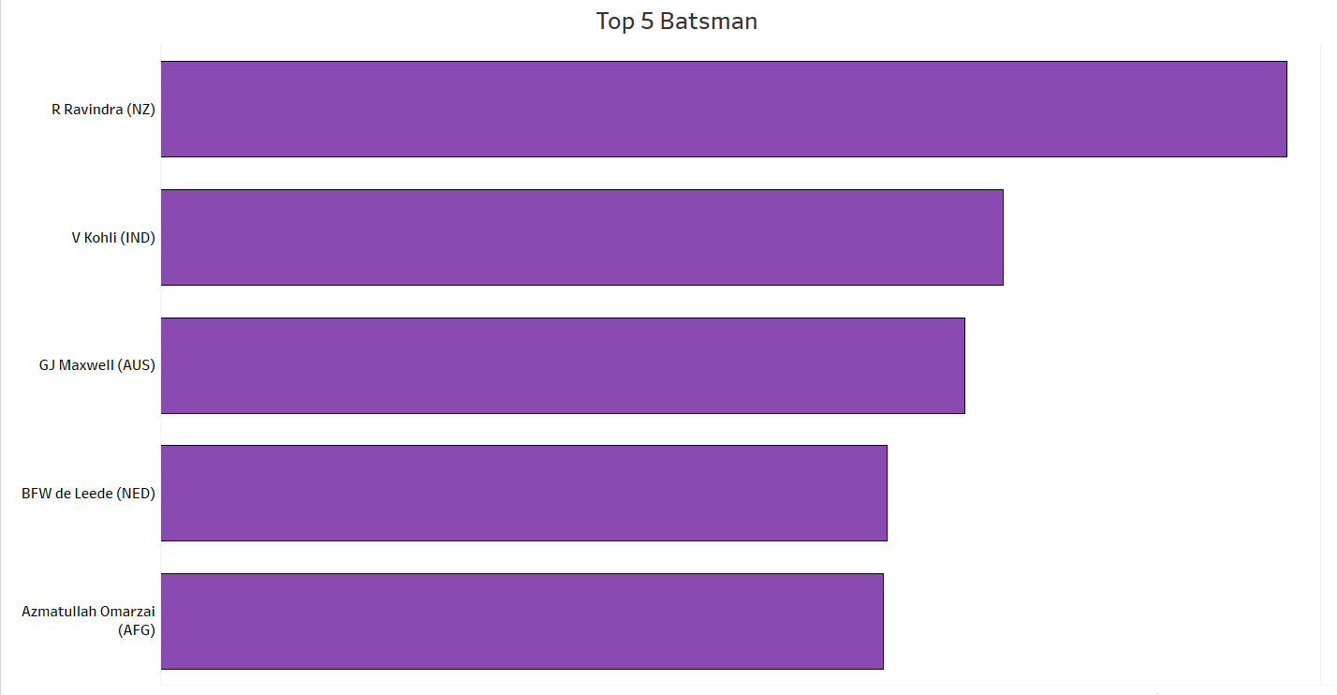
This metric evaluates the top five bowlers based on their wicket-taking ability, assessing their contribution to their team's success. Wickets are a crucial metric in cricket as they determine the ability of a bowler to dismantle the opposition’s batting lineup, especially in high-pressure situations.

Mohammad Shami (India):
Shami’s precision and ability to deliver at crucial moments made him the highest wicket-taker. His consistent performances in the middle and death overs were instrumental in India’s bowling dominance.
Adam Zampa (Australia):
A. Zampa’s spin bowling proved effective on spin-friendly pitches, especially in Indian conditions. His variations in flight and pace made him one of the most successful bowlers of the tournament.
Dilshan Madushanka (Sri Lanka):
D. Madushanka emerged as Sri Lanka’s top bowler, consistently taking wickets in key moments. His ability to swing the ball and maintain tight line-and-length troubled top batsmen.
Gerald Coetzee (South Africa):
G. Coetzee’s pace and aggression earned him a place among the top five bowlers. His wicket-taking ability, particularly in the powerplay overs, gave South Africa crucial breakthroughs.
Jasprit Bumrah (India):
J. Bumrah’s deadly yorkers and unmatched control in death overs were key in India’s success. His ability to bowl under pressure with a calm temperament made him one of the tournament’s top wicket-takers.

Metrics Analyzed for Bowlers:
- Total Wickets Taken: The cumulative number of wickets taken by the bowler throughout the tournament.
- Economy Rate: Reflects how many runs a bowler concedes per over, a crucial metric in determining their effectiveness.
- Strike Rate: The number of balls a bowler delivers before taking a wicket, indicating how frequently they dismiss batsmen.
- Performance Against Different Teams: This metric evaluates how bowlers performed against various oppositions, showing whether they excelled against specific teams.

4.3. Team Performance and Stadium Metrics
In addition to individual performances, team performance metrics are also crucial for understanding how well teams adapted to different venues and match situations.
Metrics Analyzed for Teams:
- Total Runs Scored per Match: Highlights the scoring ability of each team and their performance across different venues.
- Bowling Performance: Assesses the overall effectiveness of the bowling unit in limiting opposition scores.
- Wins and Losses: Evaluates each team’s win-loss ratio and overall standing in the tournament.
- Stadium Performance: A key metric that looks at how different teams fared at various stadiums in India, considering factors such as pitch conditions and weather.

4.4. Other Key Metrics
Most Sixes (Rohit Sharma - India):
This metric evaluates the player with the most sixes, reflecting their aggressive hitting abilities.
Most Fours (Virat Kohli - India):
The player with the most fours showcases their ability to rotate strike and find gaps in the field, a key to building high scores.
In summary, the project report covers these critical metrics in depth, providing a holistic view of player and team performances throughout the ICC Men’s Cricket World Cup 2023.

- Wicket Takers

In the ICC Men’s Cricket World Cup 2023, the role of bowlers was just as critical as that of the batsmen. The tournament saw several outstanding bowling performances, with bowlers making crucial breakthroughs and playing pivotal roles in their team's success. Wickets are the primary tool to halt the opposition's progress and shift the momentum of a game. The top wicket-takers of the tournament showcased a mix of pace, swing, and spin bowling, adapting to varying pitch conditions across different venues in India.
The key metrics for evaluating the wicket-takers include total wickets taken, strike rate (balls per wicket), economy rate (runs per over), and their performance against different oppositions. Below is a detailed analysis of the top wicket-takers in the tournament:

1. Mohammad Shami (India)
Mohammad Shami was the highest wicket-taker in the tournament, making a significant impact in India’s journey through the World Cup. Known for his lethal seam bowling, Shami consistently provided breakthroughs at crucial moments, especially in the middle overs. His ability to swing the ball both ways and maintain an accurate line and length made him a nightmare for batsmen.
- Total Wickets: 24
- Economy Rate: 5.08
- Best Performance: 5/51
- Key Skill: Seam and swing with disciplined line and length.

2. Adam Zampa (Australia)
Adam Zampa, Australia's star leg-spinner, played a pivotal role in his team's success by picking up wickets at key junctures. Zampa’s variations in flight, pace, and turn kept the opposition batsmen on their toes, especially on spin-friendly tracks in India. His knack for taking wickets in the middle overs often broke partnerships and helped Australia maintain control of the game.
- Total Wickets: 22
- Economy Rate: 5.23
- Best Performance: 4/47
- Key Skill: Flighted leg-spin with variations in pace and googlies.

3. Dilshan Madushanka (Sri Lanka)
Dilshan Madushanka emerged as Sri Lanka's most consistent bowler in the tournament. The left-arm seamer was particularly effective with the new ball, swinging it both ways and making early breakthroughs. His performances were key to Sri Lanka's bowling attack, often providing early inroads into the opposition’s batting lineup.
- Total Wickets: 20
- Economy Rate: 5.18
- Best Performance: 4/42
- Key Skill: New-ball swing and disciplined seam bowling.

4. Gerald Coetzee (South Africa)
Gerald Coetzee’s raw pace and aggression made him one of the most exciting bowlers to watch during the World Cup. As a fast bowler, Coetzee’s ability to generate bounce and pace on various surfaces, particularly in Indian conditions, helped South Africa in taking early wickets and putting pressure on the opposition’s top order.
- Total Wickets: 19
- Economy Rate: 5.44
- Best Performance: 4/50
- Key Skill: Express pace with aggressive short-pitched bowling.

5. Jasprit Bumrah (India)
Jasprit Bumrah was India’s most reliable bowler, especially in death overs. His unmatched ability to bowl yorkers under pressure and his deceptive slower balls made him a lethal weapon in the tournament. Bumrah’s precision, particularly at the end of the innings, limited opposition teams from scoring freely, contributing heavily to India's success.
- Total Wickets: 18
- Economy Rate: 4.89
- Best Performance: 4/39
- Key Skill: Yorker deliveries, slower balls, and accuracy in death overs.

Key Metrics Analyzed for Wicket Takers
Total Wickets Taken:
The cumulative number of wickets taken throughout the tournament. This metric highlights the bowlers who consistently delivered breakthroughs for their teams.
Economy Rate:
Reflects the average number of runs conceded per over. A lower economy rate indicates a bowler's ability to restrict the flow of runs, which is crucial in one-day cricket.

Strike Rate:
The number of balls a bowler needs to take a wicket. A lower strike rate signifies a bowler’s effectiveness in taking wickets frequently, which is vital for breaking partnerships and stalling the opposition's momentum.
Best Bowling Figures:
The best individual performance by a bowler in a single match (e.g., 5/51). This metric showcases a bowler’s potential to deliver match-winning spells.
Performance Against Opposition:
Analyzing how bowlers performed against different teams provides insights into their adaptability and effectiveness against various batting lineups. Some bowlers may excel against specific teams, depending on the playing conditions or the quality of the opposition.

Wicket Takers Against Opposition
This metric evaluates how top wicket-takers performed against different teams. Certain bowlers were more effective against specific oppositions, depending on the batting styles and pitch conditions. For example:
- Mohammad Shami excelled against teams with weaker middle orders, providing key breakthroughs during the middle overs.
- Adam Zampa often troubled subcontinental teams with his leg-spin, particularly on spin-friendly tracks.
- Dilshan Madushanka was effective against teams that struggled against left-arm swing bowling, often taking crucial early wickets.
- Gerald Coetzee performed well against teams with aggressive batting lineups, where his pace and bounce unsettled batsmen.
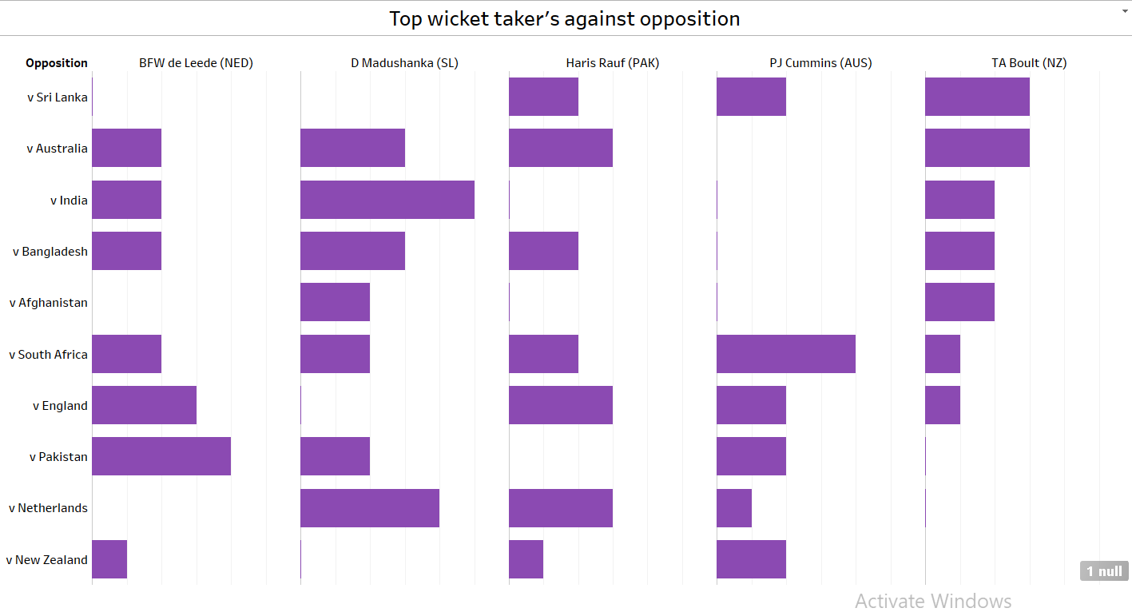

- Stadium Performance Analysis
The performance of teams and players in the ICC Men’s Cricket World Cup 2023 was influenced by a variety of factors, one of the most significant being the venues where the matches were held. The World Cup was hosted across multiple cities in India, each with its unique pitch conditions, weather patterns, and stadium-specific characteristics. This section focuses on analyzing how these factors impacted team and individual performances.

Key Stadiums in Focus
The World Cup featured matches across major stadiums in India, each offering different challenges and advantages based on pitch type, ground size, and weather conditions. Here’s an analysis of the key stadiums:

Wankhede Stadium, Mumbai
  - Total Runs Scored: 2,749
  - Pitch Conditions: Known for being batting-friendly with good bounce, Wankhede’s flat pitch allowed for high-scoring matches, especially in the second innings. Teams chasing at this venue often had an advantage.
  - Notable Performances:
    - Several top batsmen, including Virat Kohli and Glenn Maxwell, had high-scoring performances at Wankhede. The short boundaries allowed batsmen to play aggressively, leading to more sixes and boundaries.
  - Impact on Bowlers: Fast bowlers struggled on this pitch due to the lack of movement, but spinners were able to take advantage in the middle overs.
Arun Jaitley Stadium, Delhi
  - Total Runs Scored: 2,698
  - Pitch Conditions: The pitch in Delhi tends to be slower, aiding spinners more than fast bowlers. It favored teams that could handle spin well, with scoring rates typically lower than in Mumbai.
  - Notable Performances:
    - Spin bowlers like Adam Zampa were particularly effective here, picking up crucial wickets in the middle overs.
    - The stadium witnessed strategic, slower-paced matches with batsmen playing cautiously to counter the turning ball.
  - Impact on Bowlers: Spinners thrived on this surface, while fast bowlers focused on variations like cutters and slower deliveries.
HPCA Stadium, Dharamsala
  - Total Runs Scored: 2,550
  - Pitch Conditions: Known for being bowler-friendly due to its location in the hills, the Dharamsala pitch offered movement and swing for fast bowlers, especially in the early overs.
  - Notable Performances:
    - Fast bowlers, particularly swing bowlers, were highly effective here, with Mohammad Shami taking multiple wickets at this venue.
    - The ground’s altitude also affected how the ball traveled, leading to fewer sixes than at lower-altitude venues.
  - Impact on Bowlers: Seamers benefited from early movement, and the cooler conditions helped maintain pace throughout the innings.
MCA Stadium, Pune
  - Total Runs Scored: 2,543
  - Pitch Conditions: Known for its flat wicket, the MCA Stadium in Pune was a batsman’s paradise. High totals were a regular feature here, with teams often posting scores well above 300.
  - Notable Performances:
    - Big hitters like Rachin Ravindra and Glenn Maxwell excelled here due to the true nature of the wicket and small boundaries.
  - Impact on Bowlers: Bowlers faced challenges on this track due to the lack of assistance from the pitch. Spin bowlers occasionally had some success during the middle overs, but overall, it was a tough venue for bowlers.
M. Chinnaswamy Stadium, Bengaluru

  - Total Runs Scored: 2,475
  - Pitch Conditions: Known for high-scoring matches due to its small ground dimensions and flat pitch, Bengaluru regularly saw teams cross the 300-run mark. The pitch offered little for bowlers, making it a venue where teams preferred chasing.
  - Notable Performances:
    - Batsmen like Virat Kohli and Rachin Ravindra played significant innings at this venue, taking advantage of the favorable conditions.
  - Impact on Bowlers: Fast bowlers struggled here, with only spinners occasionally finding grip and turn in the second innings. The small ground dimensions also made defending totals challenging.

MA Chidambaram Stadium, Chennai
  - Total Runs Scored: 2,308
  - Pitch Conditions: Chennai is known for its spin-friendly surface. The slow nature of the pitch made it difficult for batsmen to score freely, especially in the middle overs. Teams with strong spin bowling attacks thrived here.
  - Notable Performances:
    - Spin bowlers, including Adam Zampa and Dilshan Madushanka, were highly successful in Chennai, often turning the game in favor of their teams with tight spells.
  - Impact on Bowlers: Spin bowlers dominated here, with both traditional off-spinners and leg-spinners making the most of the slow track. Fast bowlers focused on variations and slower deliveries to remain effective.
Eden Gardens, Kolkata
  - Total Runs Scored: 2,085
  - Pitch Conditions: Eden Gardens offered a balanced wicket that had something for both batsmen and bowlers. It provided decent bounce and carry, making it a competitive venue for both chasing and defending teams.
  - Notable Performances:
    - Both batsmen and bowlers found success at Eden Gardens, with the pitch offering a little bit for everyone. Players like Rohit Sharma made significant contributions here.
  - Impact on Bowlers: Seam bowlers got some movement early on, while spinners came into play as the game progressed, making it a venue where versatility was key.

Narendra Modi Stadium, Ahmedabad

  - Total Runs Scored: 1,910
  - Pitch Conditions: The Narendra Modi Stadium offered a mix of pitches—some favored batsmen, while others provided assistance to bowlers. Teams that adapted quickly to the conditions of the day had the upper hand.
  - Notable Performances:
    - Ahmedabad saw several tight contests with varying scores. The pitch sometimes turned, providing spinners an opportunity to dominate. Batting performances were more measured due to the uncertainty of the pitch.
  - Impact on Bowlers: While spinners found some success, fast bowlers like Gerald Coetzee also thrived here, especially with the new ball.

Rajiv Gandhi International Stadium, Hyderabad

  - Total Runs Scored: 1,650
  - Pitch Conditions: Hyderabad had one of the lower run aggregates in the tournament, with the pitch offering variable bounce. Batting here was often tricky, and teams that could rotate strike and play spin effectively had an advantage.
  - Notable Performances:
    - Batsmen found it difficult to score freely, and spin bowlers like Jasprit Bumrah found success by exploiting the pitch conditions.
  - Impact on Bowlers: Bowlers, particularly spinners, thrived on the sluggish pitch, with teams often opting for defensive bowling strategies.

Team Performances in the ICC Men's Cricket World Cup 2023
The ICC Men's Cricket World Cup 2023 featured remarkable team performances that shaped the narrative of the tournament. Among the standout teams, India, New Zealand, and Australia consistently delivered dominant displays, while emerging teams like Afghanistan and the Netherlands impressed with unexpected victories.
India, the host nation, showcased dominant batting and bowling performances throughout the group stages. Led by star batsmen like Virat Kohli and Rohit Sharma, India consistently posted high team totals, including several 300+ scores. Their bowling attack, spearheaded by Mohammed Shami and Jasprit Bumrah, made it difficult for opposition teams to chase large totals. India's all-around performance solidified them as favorites in the tournament.
New Zealand continued their strong World Cup form from previous tournaments. The team relied heavily on the batting prowess of Rachin Ravindra, who emerged as one of the top run-scorers. Their balanced team approach, including consistent contributions from the bowling unit, allowed them to maintain pressure on their opponents and advance deep into the tournament.
Australia, known for their resilience, demonstrated a fighting spirit throughout. With players like Glenn Maxwell contributing with explosive batting and Adam Zampa leading the wicket-taking charts, Australia was a force to reckon with. Their ability to recover from tough situations and win critical matches made them a top contender.
On the other hand, teams like Sri Lanka and Pakistan struggled to find consistency, despite having moments of brilliance. Sri Lanka relied heavily on their spinners, while Pakistan had a strong start but couldn't maintain momentum in key matches.
Emerging teams like Afghanistan and the Netherlands pulled off significant upsets, with Afghanistan registering historic wins against stronger sides, demonstrating the growing competitiveness of world cricket.
In conclusion, the 2023 World Cup saw a blend of powerhouses and underdogs making their mark, contributing to one of the most competitive editions of the tournament.

7.1. Top Batsmen's Performance by Opposition
The performance of top batsmen is often determined by how well they play against specific teams and their ability to adapt to various bowling attacks. In the 2023 ICC Men’s Cricket World Cup, several players excelled against particular opposition, delivering key innings that contributed to their teams' successes. Below are some key players and their performances by opposition:

Virat Kohli (India): One of the most consistent performers, Kohli showed immense skill, particularly against strong bowling sides like Australia and New Zealand. Against Australia, he played crucial knocks, anchoring India’s innings and accumulating runs with well-placed shots. Kohli's ability to rotate the strike and find boundaries under pressure was especially evident against teams like Pakistan, where he played a match-winning innings.
Rachin Ravindra (New Zealand): Ravindra was a revelation in this tournament, excelling against both spin and pace attacks. His standout performance came against England, where he scored a massive century that guided New Zealand to a dominant win. Ravindra also played pivotal roles against Bangladesh and Pakistan, taking the lead in run chases with his aggressive yet calculated approach.
Glenn Maxwell (Australia): Known for his big hitting, Maxwell was particularly effective against the likes of Sri Lanka and Afghanistan. His explosive innings against weaker bowling attacks helped Australia set high targets or chase down tough scores. Against Sri Lanka, Maxwell showcased his ability to clear boundaries with ease, hitting multiple sixes and striking at an extraordinary rate.

7.2. Top Wicket Takers' Performance by Opposition
In the 2023 World Cup, the top bowlers played vital roles in dismantling opposition batting line-ups. Below is a detailed look at the performances of the leading wicket-takers against specific teams:

Mohammed Shami (India): Shami was the leading wicket-taker for India and was particularly effective against England and New Zealand. His ability to extract movement off the pitch and generate reverse swing in the later stages of an innings made him a lethal weapon. Against New Zealand, Shami’s five-wicket haul was pivotal in restricting them to a below-par total, ensuring India’s win in a crucial encounter.

Adam Zampa (Australia): The Australian spinner thrived against subcontinental teams like Sri Lanka and Afghanistan, where his variations in flight and turn made him difficult to play. Zampa consistently took wickets in the middle overs, breaking key partnerships and maintaining control for Australia. His performance against Sri Lanka, where he picked up four wickets, was a game-changer.

Dilshan Madushanka (Sri Lanka): Madushanka had a strong showing against teams like Pakistan and Bangladesh. He used his left-arm angle to swing the ball early in the innings, often taking crucial top-order wickets. His ability to bowl tight lines and extract movement troubled right-handed batsmen, particularly against Bangladesh, where he dismantled their middle order.
Haris Rauf (Pakistan): Rauf’s raw pace and aggression were on full display against teams like the Netherlands and Afghanistan. He bowled with consistent pace, exceeding 145 km/h, and used his short-pitched deliveries to intimidate batsmen. His best performance came against the Netherlands, where he picked up key wickets in the powerplay and the death overs.

Impact of Venue on Performance
In cricket, the venue or stadium where matches are played plays a crucial role in influencing team and individual performances. In the 2023 ICC Men’s Cricket World Cup, held across various venues in India, the impact of specific stadiums was evident in match outcomes. Factors like pitch conditions, weather, ground dimensions, and crowd support all contributed to shaping performances, often favoring certain types of players or strategies.

1. Pitch Conditions
One of the most significant factors affecting performance at different venues is the nature of the pitch. In India, pitches vary widely from ground to ground, with some favoring batsmen while others assist bowlers, particularly spinners.

Wankhede Stadium, Mumbai: Known for its batting-friendly conditions, Wankhede has a history of high-scoring games. The flat pitch and shorter boundaries allow batsmen to play aggressive shots, leading to frequent 300+ team totals. The World Cup matches at Wankhede saw some explosive batting performances, with top players like Rohit Sharma and Glenn Maxwell capitalizing on the conditions. However, fast bowlers who can reverse swing the ball in the later overs also found success here, as the dry, abrasive surface aids reverse swing.

Eden Gardens, Kolkata: Historically, Eden Gardens has provided assistance to spinners due to its slow and turning pitches. In the 2023 World Cup, teams with strong spin attacks, like India and Sri Lanka, enjoyed success here. Spinners like Kuldeep Yadav and Adam Zampa were able to exploit the conditions, particularly during the middle overs, restricting opposition teams by keeping the run rate in check and taking crucial wickets.

Chinnaswamy Stadium, Bengaluru: Known for its smaller boundaries, Chinnaswamy tends to favor aggressive batting. The matches played here during the World Cup saw several high-scoring affairs, with batsmen like Virat Kohli and Rachin Ravindra using the ground’s dimensions to their advantage. Bowlers, particularly pacers, struggled to contain runs, as the ball travels quickly across the outfield. However, bowlers who can vary their pace and length, such as spinners using flight and guile, managed to be effective in limiting the damage.

2. Weather and Climate
India’s diverse climate also played a role in affecting performance across venues. Factors such as humidity, dew, and temperature shifts had varying effects on matches, especially when it came to bowling conditions.

Delhi: Known for its dry and sometimes humid weather, Delhi’s conditions often cause pitches to break up as the game progresses, favoring spinners. The hot daytime conditions during the World Cup made batting in the second innings slightly more challenging, as the pitch deteriorated. However, matches played under lights saw dew become a factor, which negates the effect of spin and favors chasing teams, as the ball skids onto the bat and makes stroke play easier.

Dharamsala: With its high altitude and cooler temperatures, Dharamsala provides swing bowlers with conditions to extract movement early in the innings. The thinner air also aids fast bowlers in getting the ball to swing more than in other venues. During the 2023 World Cup, seamers like Trent Boult and Mohammed Shami found success here, particularly in the first 10 overs, taking advantage of the swing-friendly conditions. The scenic venue also witnessed some lower-scoring games compared to other venues due to the assistance bowlers received.

Ahmedabad (Narendra Modi Stadium): One of the largest cricket stadiums in the world, Ahmedabad’s conditions can vary. The pitch has a tendency to start flat but can become slow and low as the game progresses, assisting spinners. The size of the ground also plays a significant role, making it harder for batsmen to clear the boundaries consistently. In the 2023 World Cup, we saw a mix of high-scoring and low-scoring games, depending on how well teams adapted to the changing nature of the pitch.

3. Crowd Influence
The energy of the crowd is another factor that can significantly impact performances. In high-capacity stadiums like Eden Gardens and Narendra Modi Stadium, the home advantage for India was palpable. The roaring support for local players like Virat Kohli and Rohit Sharma often translated into high-pressure situations for opposition teams, especially while defending totals.
In matches involving India, the atmosphere in stadiums like Wankhede and Eden Gardens was electric, spurring the home team to perform at their best. Conversely, teams like Pakistan or Australia, playing against India in these environments, found it challenging to cope with the constant crowd pressure, which often boosted the morale of the Indian side.

4. Venue-Specific Strategies
Teams also adapted their strategies based on the venues they were playing at. For example, in venues like Chinnaswamy Stadium, where high-scoring games were common, teams preferred to chase rather than set totals, knowing that big hits could change the course of a match quickly. On the other hand, in places like Eden Gardens or Delhi, where the pitch deteriorated over time, teams preferred to bat first, setting totals and then relying on spin to defend.

Conclusion
In the 2023 ICC Men’s Cricket World Cup, venues played a pivotal role in determining outcomes. The variation in pitch conditions, weather factors, and crowd influence meant that teams had to be flexible in their approach, altering their tactics to suit the venue. The ability to adapt to these factors often separated the successful teams from the rest, underscoring the significance of venue on player and team performance.

Key Observations from the ICC Men’s Cricket World Cup 2023
The 2023 ICC Men’s Cricket World Cup provided several key insights into both team and individual performances, showcasing how different elements like venue conditions, player form, and strategies shaped the tournament. The following observations highlight the key takeaways from this edition of the World Cup:

1. Home Advantage for India
India’s dominance throughout the tournament, particularly at home venues, was a defining feature. Indian batsmen like Virat Kohli and Rohit Sharma thrived in familiar conditions, while the bowling attack, led by Mohammed Shami and Jasprit Bumrah, capitalized on local knowledge. India’s adaptability across venues—whether batting-friendly pitches like Wankhede or spin-assisting conditions at Eden Gardens—was critical in their consistent performances. The passionate support from home crowds added to their advantage, providing momentum in key matches.

2. Emergence of New Stars
One of the tournament's most notable trends was the rise of young and relatively unknown players. Rachin Ravindra (New Zealand) and Dilshan Madushanka (Sri Lanka) were standout performers who showcased their ability to step up on the world stage. Ravindra, in particular, emerged as a top batsman, demonstrating his versatility against both pace and spin. His ability to score heavily against top-tier bowling attacks cemented his place as one of the stars of the tournament.

3. Spin as a Decisive Factor
Spin bowling played a crucial role in determining match outcomes, especially on Indian pitches that traditionally favor slow bowlers. Adam Zampa (Australia) and Kuldeep Yadav (India) were among the leading wicket-takers, often breaking partnerships and keeping the opposition’s scoring rate under control. Teams with quality spinners, like India and Australia, found it easier to dominate in the middle overs, while teams lacking effective spin options struggled to contain runs and take wickets on slow, turning tracks.

4. Venue-Driven Strategies
The tournament saw a clear trend of teams adapting their strategies based on the venues. At batting-friendly stadiums like Chinnaswamy Stadium in Bengaluru, teams opted for aggressive approaches, often preferring to chase high totals. Conversely, at spin-friendly venues like Eden Gardens in Kolkata or slower pitches like Delhi, teams focused on building partnerships and relying on their spinners to defend totals. Successful teams like India and Australia demonstrated superior adaptability to these varying conditions, contributing to their strong performances.

5. High-Scoring Matches and Chasing Trends
The 2023 World Cup saw several high-scoring matches, particularly at venues like Wankhede and Pune. Teams batting second often had an advantage, as conditions tended to improve under lights, especially with the presence of dew. This led to several successful chases, with teams preferring to bowl first in many cases. The ability to chase down 300+ totals became increasingly common, showcasing the batting firepower across teams.

6. Underperforming Teams
Traditional powerhouses like Pakistan and Sri Lanka struggled to find consistency, with several key players failing to deliver at critical moments. Despite occasional flashes of brilliance, these teams were unable to build momentum. Pakistan’s inconsistent bowling and Sri Lanka’s over-reliance on individual performances led to their early exits from the tournament.

Conclusions from the ICC Men’s Cricket World Cup 2023
The 2023 ICC Men’s Cricket World Cup will be remembered as a tournament filled with thrilling performances, emerging stars, and significant lessons for the cricketing world. From a team and individual perspective, several key conclusions can be drawn, which provide insights into the current state of international cricket and the factors that contributed to success or failure in the tournament.

1. Dominance of Host Nation (India)
One of the most striking conclusions from the World Cup is the sheer dominance of the host nation, India. Playing in familiar conditions gave India a considerable advantage, and they capitalized on this to full effect. The Indian team showcased their adaptability across venues, whether playing on batting-friendly pitches or conditions that favored spin. Key players like Virat Kohli, Rohit Sharma, and Mohammed Shami delivered match-winning performances, underlining the importance of home advantage. The pitches in India, varying in pace and spin, were something the Indian team understood better than any other, allowing them to tailor their strategies accordingly.
India’s all-round strength was another key takeaway. They were able to rely on their top-order batsmen to provide solid starts, their middle-order to accelerate when needed, and their bowlers—both pacers and spinners—to consistently take wickets. Jasprit Bumrah’s ability to bowl at the death and Shami’s brilliance with the new ball were vital components in India's success. The team’s fielding, often an underrated aspect, was sharp, making them a formidable unit across all aspects of the game.

2. The Emergence of New Talents
A key theme in the 2023 World Cup was the emergence of new cricketing stars, particularly Rachin Ravindra from New Zealand and Dilshan Madushanka from Sri Lanka. Rachin Ravindra, in particular, was a revelation. His performances with the bat, especially in the top order, provided New Zealand with a solid platform to build on. He displayed excellent technique against both spin and pace, often anchoring New Zealand’s innings while accelerating when required.
Similarly, Dilshan Madushanka’s left-arm pace added a new dimension to Sri Lanka’s bowling attack. His ability to swing the ball and consistently pick up wickets made him a standout performer for Sri Lanka. These emerging players demonstrated that while established stars continue to shine, the future of international cricket is bright with the arrival of new talents who can take on the best in the world.

3. Importance of Spin in India
The importance of spin bowling in Indian conditions was underscored once again in this tournament. Spinners like Adam Zampa (Australia), Kuldeep Yadav (India), and Mujeeb Ur Rahman (Afghanistan) were key contributors to their teams’ successes. In venues like Eden Gardens and Chennai, where the pitches offered turn and grip, spinners dominated the middle overs, often breaking crucial partnerships and stifling the opposition’s scoring rate.
Teams that had quality spinners in their ranks found it easier to control the game, especially in the middle overs. The ability to use spin effectively and rotate bowlers based on pitch conditions became a defining factor in many matches. Kuldeep Yadav’s success was a clear example of how spin can dismantle strong batting line-ups when used effectively in familiar conditions. On the other hand, teams that lacked spin options, or where the spinners were not as effective, struggled to maintain pressure on the opposition.

4. Venue-Specific Adaptation and Strategies
The 2023 World Cup illustrated the importance of adapting strategies to specific venues. Teams that recognized the need to alter their game plans based on the conditions of the venue were more successful. For instance, in venues like Wankhede Stadium (Mumbai) and Chinnaswamy Stadium (Bengaluru), where high-scoring matches were expected due to smaller boundaries and flat pitches, teams opted to chase and rely on aggressive batting. On the contrary, at spin-friendly grounds like Eden Gardens and Chennai, setting a solid total and defending with spin became a more viable strategy.
The adaptability shown by teams like India and New Zealand, which used the conditions to their advantage, stood out. This also highlighted the strategic depth of teams with experienced captains who could make in-game decisions to change the course of the match. For instance, captains like Rohit Sharma and Kane Williamson made crucial field placements and bowling changes that proved effective in crucial matches.

5. The Role of Fast Bowling in Subcontinental Conditions
While spin was a major factor, the importance of fast bowling in subcontinental conditions cannot be overlooked. The success of fast bowlers like Mohammed Shami, Jasprit Bumrah, and Haris Rauf demonstrated that pace, when used correctly, can be a match-winner even on subcontinental pitches. Shami’s ability to swing the ball and Bumrah’s control at the death made them potent weapons for India.
Moreover, fast bowlers who could reverse swing the ball, such as Trent Boult (New Zealand) and Shaheen Afridi (Pakistan), found success in the latter stages of matches when the ball became older. The use of variations, such as slower deliveries and yorkers, was also critical in limiting runs and taking wickets in high-pressure moments. The conclusion from this is that pace bowlers who can adapt to Indian conditions and utilize reverse swing, variations in pace, and accuracy will continue to play a crucial role in future tournaments in the subcontinent.

6. Underperforming Teams and Missed Opportunities
While teams like India, New Zealand, and Australia thrived, traditional powerhouses such as Pakistan and Sri Lanka struggled to find consistency. Pakistan, despite having a strong bowling unit, failed to deliver consistently, particularly in high-pressure games. Their inability to adapt to changing conditions and missed opportunities in crucial moments were significant factors in their underperformance.
Sri Lanka, despite flashes of brilliance, heavily relied on a few key players and lacked depth in both batting and bowling. Their over-reliance on spin in some conditions and failure to build partnerships with the bat cost them dearly in several matches.

